Title of Abstract
Name, Company/University, Country

Abstract (300 word limit)
Encyclopedia of Bioanalytical Methods for Bioavailability and Bioequivalence Studies of Pharmaceuticals: It is a unique encyclopedia involving bioanalytical methods for bioavailability and bioequivalence (BA/BE) studies of pharmaceuticals for suitable method selection with thousands of combinations and searches against these methods. Required information for regular method development or validation such as IUPAC name, structure, solubility, chromatographic conditions, instrumentation information like HPLC, LCMS detection parameters, sample preparations, recovery details, limit of detection and limit of quantification, Tmax, Cmax etc., for routine application in BA/BE studies of pharmaceuticals was incorporated including official pharmacopeias information such as European Pharmacopeia, Japan Pharmacopeia and US Pharmacopeia. Keen selections of bioanalytical methods for pharmaceutical analysis or regular quality control are also possible with E-BABE.

Image
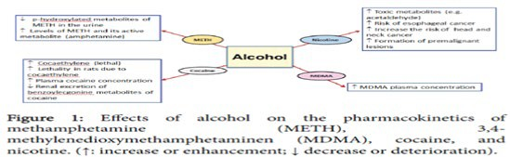
Recent Publications (minimum 5)
- Harper C (2009) The neuropathology of alcohol-related braindamage. Alcohol Alcohol 44:136-140.
- Heilig M, Egli M (2006) Pharmacological treatment of alcohol dependence: Target symptoms and target mechanisms. Pharmacology and therapeutics 111:855-876.
- LiX, SchwachaMG, ChaudryIH, ChoudhryMA (2008)Acutealcohol intoxication potentiates neutrophil-mediated intestinal tissue damage after burn injury. Shock 29:377.
- Room R, BaborT, Rehm J (2005) Alcohol and public health. Lancet
365: 519-530.
5. Sullivan EV, Zahr NM (2008) Neuroinflammation as a neurotoxic mechanism in alcoholism: Commentary on “Increased MCP- 1 and microglia in various regions of human alcoholic brain”. Experimental neurology 213:10-17.

Biography (150 word limit)
Name has studied in University and working as a faculty in University. Name has his/her expertise in evaluation and passion in improving the health and wellbeing. His/Her open and contextual evaluation model based on responsive constructivists creates new pathways for improving healthcare.
Email: XXXXXXX@xxxmail.com

Notes/Comments:

