

Title: Homology Modelling of Lycopene Cleavage Oxygenase: The Key Enzyme of Bixin Production
Author (s) Name: xxxx, yyyyy, zzzzz
XYZ University, Europe

Bixin is a natural dye and a high commercial important compound, produced from Bixin synthetic pathway in case of Bixa orellana plant. The particular enzyme Lycopene cleavage Oxygenase catalyzes the fi rst step of reaction pathways from Trans-lycopene to Bixin synthesis. The 3D structure of the enzyme was predicted by MODELLER program and the missing side chains were verifi ed by SCRWL4 tool. Model validation was done by using the output of PROCHECK and DOPE score. The Ramachandran plot for the model was observed as 87.3 percentages of residues is in favourable regions that indicate the model is reliable. (Up to 250 words)

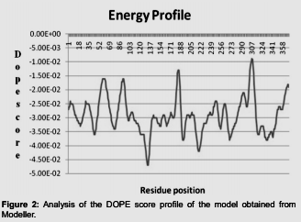
Figures if any (BW/Color):
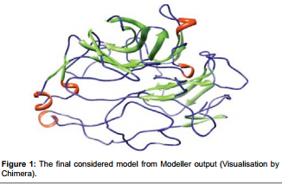

Biography

XXXX has completed his PhD from XXX University. He is the Head of the department of XXXX, a premier research organization. He has published more than 35 papers in reputed journals and has been serving as an editorial board member of repute journals. (Up to 100 words)
Presenting author details
Full name:
Contact number:
Email id:
Category: (Oral presentation/ Poster presentation)
Session name:
Research interest:

