Title: Nano-particles for enhancing productivity, profitability and resource use efficiency of Indian mustard (Brassica juncea) under semi arid conditions
Serina Ruth, Ph D, Department of Materials Engineering, TLI Foundation, USA.
Serina Ruth, Ph D, Department of Materials Engineering, TLI Foundation, USA.

Abstract (300 word limit):

The low productivity and consequently poor economics from Indian mustard under semi arid conditions is major worrisome cause. The response to Indian mustard for technical inputs is very good and their use efficiency and total factor productivity can be enhanced through use of nano particles. The nano-particles (Chitosan and Titanium oxide) were used to enhancing resource use efficiency of Brassica juncea and seed treatment with Titanium oxide @1000 ppm was best in terms of yield enhancement Nanoparticles are materials that are very small, fall within the nanometric range, with at least one of their dimensions being less than a few hundred nanometers. Chitosan Nano Particles ,purity: >99%, 80-150nm size and Titanium Oxide Nanopowder (TiO2, anatase, 99+%, 10-25 nm) were used as seed treatment and foliar spray of different concentration in Indian mustard. The smaller size at atomic level of nano particles changes their properties. Among all the treatment combination, the seed treatment with Titanium oxide @1000 ppm resulted in maximum increase in seed yield, also higher harvest index, oil productivity, profitable efficiency and economics was recorded due to seed treatment with Titanium oxide. The unique physico-chemical, optical and biological properties of Titanium oxide resulted in better growth and seed productivity. Most of these effects of are related to the appearance of quantam effects as the size decreases, and are the origin of phenomena such as Plasmon resonance etc. Nanoparticles may help to improve nutrient use efficiency because of their small size, more surface area and their slow rate of release, which facilitate to the plants to take up most of the nutrients without any waste. Nano TiO2 improved seed yield due to the photo catalyst ability of nano sized TiO2 which led to increase in photosyntheticrate.

Image
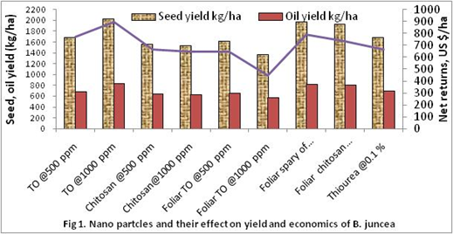Figure 1: Nano particles and their effect on yield and economics of B. juncea
Recent Publications (minimum 5)
- Rathore S.S., Chaudhary D.R., Boricha G.N., Ghosh A., Bhatt B.P., Zodape S.T., Patolia J.S. 2009. Effect of seaweed extract on the growth, yield and quality of soybean (Glycine max) under rainfed conditions. South African Journal of Botany. 75 . 351–355.
- Rathore Sanjay Singh, Kapila Shekhawat, Om Prakash Premi, Basant Kumar Kandpal and Jitendra Singh Chauhan. 2014. Biology and management of the fast-emerging threat of broomrape in rapeseed–mustard. Weed Biology and Management 14, 145–158 (2014)
- Rathore SS, N Krose, Moa Naro, Kapila Shekhawat & BP Bhatt. 2012. Weed management through salt application: An indigenous method from shifting cultivation areas, Eastern Himalaya, India. Indian Journal of Traditional Knowledge 11(2): 354-357.
- Bhatt B.P., S.S. Rathore, Moanaro Lemtur , Bikash Sarkar. 2016. Fuel wood energy pattern and biomass resources in Eastern Himalaya. Renewable Energy 94 , 410-417
- Rathore S. S., Kapila Shekhawat, Anchal Dass, B. K. Kandpal & V. K. Singh. 2017. Phytoremediation Mechanism in Indian Mustard (Brassica juncea) and Its Enhancement Through Agronomic Interventions.Proc. Natl. Acad. Sci., India, Sect. B Biol. Sci.DOI 10.1007/s40011-017-0885-5.

Biography (150 word limit)
Fifteen years of working research experience at National dairy Development Board, CAR C-NEH Region, Directorate of Rapeseed-Mustard Research and ICAR-Indian Agricultural Research Institute, New Delhi. Specialized in farming system research under hill and shifting cultivation for higher income, micro-irrigation and resource conservation technologies in mustard based cropping system. Handled externally funded and institute projects. Published >65 international and national research papers, ten bulletin, four extension folders, 15 book chapters and one book. Also handled 10 externally funded project including World Bank sponsored and 12 institutional projects.
E mail: xxxxxxx@xxxxxmail.com

NOTES/ COMMENTS:

