Manufacturing of alkene phosphatases from marine organisms with potential functions and industrial applications
XXXX, RN PhD, TLI Foundation, USA
XXXXXX, RN PhD, TLI Foundation, USA

Abstract (300-word limit)
Statement: Over half the population of US is crowded close to the shores, partly because of entertaining and artistic considerations. More and more, however, the near shore ocean is the receiver of a multitude of toxic or aggressive materials. Until recently the oceans with their vastarea and volume have seemeda safe site for the disposal of wastes. Recent events are causing second thoughts. (ABELSON, 1971).
Methodology and Theoretical Orientation:
Findings:
Conclusion and Significance:
Image:
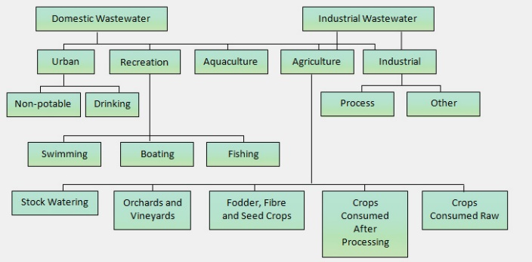
Recent Publications (minimum 5)
- Recent research studies by NOAA scientists have shown that even insignificant amounts of petroleum.(IXTOC I, 1979)
- Heilig M, Egli M (2006) Pharmacological treatment of alcohol dependence: Target symptoms and target mechanisms. Pharmacology and therapeutics 111:855-876.
- Li X, Schwacha MG, Chaudry IH, Choudhry MA (2008) Acute alcohol intoxication potentiates neutrophil-mediated intestinal tissue damage after burn injury. Shock 29:377.
- Bell PR (1992) Eutrophication and coral reefs – some examples in the Great Barrier Reef lagoon. Wat Res 26:553–568
5. Sullivan EV, Zahr NM (2008) Neuroinflammation as a neurotoxic mechanism in alcoholism: Commentary on “Increased MCP-1 and microglia in various regions of human alcoholic brain”. Experimental neurology 213:10-17.

Biography (150-word limit)
Smith Walker has his/her expertise in xxxxxxx. His/Her open and contextual evaluation model based on xxxxxxxx. He/She has built this model after years of experience in research, evaluation, teaching and administration in organization. The foundation is based on fourth generation evaluation (Guba& Lincoln, 1989) which is a methodology that utilizes the previous generations of evaluation: measurement, description and judgment. It allows for value-pluralism. This approach is responsive to all stakeholders and has a separate way of focusing.
Email: andrXXX@xxxmail.com

Notes/Comments

