Title: Psychiatry and its relation.
Author Name, Degree, Organization Name, Country
e.g.: Anitha Kumar, PhD, MAAmalti Rehabilitation Centre, USA
- Abstract (300-word limits)
- Statement of the Problem
- Methodology & Theoretical Orientation
- Findings
- Conclusion & Significance
- Image (Optional)
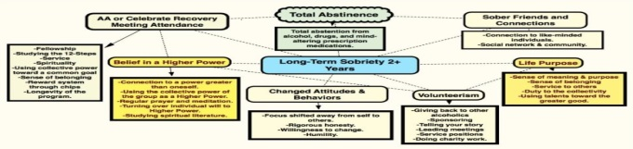
- Recent Publications [minimum-2 (If you have or leave this section)]
e.g.: Anitha Kumar, P. K. (2015). Psychiatry and its relation, Counselling, Journal of Psychiatry, 15 (2), 17-19
- Biography with Author image (150-word limits)
Anitha Kumar is the Founder of MAAmalti psychiatry Centre. Kumar founded MAAmalti with the vision of helping people with addictions recover and learn to live for life. Kumar has worked in the field of addictions and psychology for more than 10 years. Kumar is the Past President of the Association of Psychotherapists and Counselors (Singapore) and the Regional Director of the Asia Pacific Certification Board (Singapore) while being one of the founding members as well. Kumar is a certified practitioner in Management of Family Violence Counseling, Certified Clinical Supervisor, Certified Substance Abuse Therapist (Level 4) and a Certified Psychotherapist and Counselor (Level 4).
- Presenting author details
- Full name:
- Email:
- Contact number:
- Research Interest:
- Current designation:
- Twitter account:
- Facebook account:
- LinkedIn account:
- Category: (Oral presentation/ Poster presentation/ Workshop)

Notes/Comments:

