Title: E-BABE-Encyclopedia of Bioanalytical Methods for Bioavailability and Bioequivalence Studies of Pharmaceuticals

Name: xxxxxxxx
Stanford University School of Medicine, USA

Abstract (300 word limit)

Encyclopedia of Bioanalytical Methods for Bioavailability and Bioequivalence Studies of Pharmaceuticals (E-BABE): It is a unique encyclopedia involving bioanalytical methods for bioavailability and bioequivalence (BA/BE) studies of pharmaceuticals for suitable method selection with thousands of combinations and searches against these methods. Most scrutinized literature was collected from different sources including PubMed. This database has been curetted using published methods for all most all pharmaceuticals. Required information for regular method development/validation such as IUPAC name, structure, solubility, chromatographic conditions, instrumentation information like HPLC, LCMS detection parameters, sample preparations, recovery details, limit of detection and limit of quantification, Tmax, Cmax etc., for routine application in BA/BE studies of pharmaceuticals was incorporated including official pharmacopeias information such as European Pharmacopeia, Japan Pharmacopeia and US Pharmacopeia. Keen selections of bioanalytical methods for pharmaceutical analysis or regular quality control are also possible with E-BABE. E-BABE was built understanding the needs of pharmaceutical industry and laboratories including CROs working on BA/BE studies. Presently it has nearly of 5,000 methods and it will be updated regularly.

Image
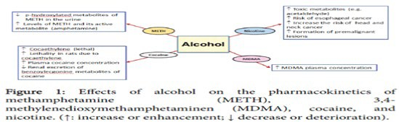
Recent Publications
- Xxxxxxx
- Xxxxxxxx
- Xxxxxxxx
- Xxxxxxxx
- xxxxxxxxx

Paste your university/ organization Logo here
Paste your Photograph Here
Biography (150 word limit)
Xxxxxxxxx has his/her expertise in evaluation and passion in improving the health and wellbeing. Her open and contextual evaluation model based on responsive constructivists creates new pathways for improving healthcare. She has built this model after years of experience in research, evaluation, teaching and administration both in hospital and education institutions. The foundation is based on fourth generation evaluation (Guba& Lincoln, 1989) which is a methodology that utilizes the previous generations of evaluation: measurement, description and judgment. It allows for value-pluralism. This approach is responsive to all stakeholders and has a different way of focusing.
Email: drXXXXXXX@xxxmail.com

\

