Title of the Presentation:
Speaker Name:
Speaker Affiliation:
Track Name:

Abstract (300 word limit)
Content of the abstract: For example:
Membrane Separation Processes-The separation techniques that are uniquely physical in nature and operate without the usage of heat and thus utilizing least energy as compared to the orthodox Thermal Separation Methods.
In 2014, the International Membrane Market Analysis shows that Asia-Pacific and North-America, accounted for the major share acquisition. U.S., in North America was the largest consumer of Membranes. The driving forces of the Membrane Market are water & wastewater treatment, pharmaceuticals & medical uses, food and beverages, and chemical processing sectors. The Middle-East Asia region is anticipated to catalog the highest growth rates for the membrane market because of the demand for desalination and wastewater treatment units in the region and is followed by LATAM in terms of growth rate.
Water and wastewater treatment and pharmaceuticals and medical segments become the prime reason for maximum segment in the membranes market with approximately 62% share in 2014. Concentrated growth is probable from industrial gas processing and others segments in the near future. The accumulative use of membranes in the oil and gas fields for gas processing, hydrogen production, carbon dioxide removal from natural gas streams, and so on are likely to motivate the development in the membranes market from 2015 to 2020. Also, the demand for membranes is envisioned to get incremented in the future with the growth of the emerging economies further strengthening the market.

Image
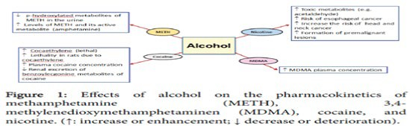
Recent Publications (minimum 5)
- Harper C (2009) The neuropathology of alcohol-related braindamage. Alcohol Alcohol 44:136-140.
- Heilig M, Egli M (2006) Pharmacological treatment of alcohol dependence: Target symptoms and target mechanisms. Pharmacology and therapeutics 111:855-876.
- LiX, SchwachaMG, ChaudryIH, ChoudhryMA (2008)Acutealcohol intoxication potentiates neutrophil-mediated intestinal tissue damage after burn injury. Shock 29:377.
- Room R, BaborT, Rehm J (2005) Alcohol and public health. Lancet
365: 519-530.
5. Sullivan EV, Zahr NM (2008) Neuroinflammation as a neurotoxic mechanism in alcoholism: Commentary on “Increased MCP- 1 and microglia in various regions of human alcoholic brain”. Experimental neurology 213:10-17.

Biography (150 word limit)
Deanna Mulvihill has her expertise in evaluation and passion in improving the membrane science. Her open and contextual evaluation model based on responsive constructivists creates new pathways for improving healthcare. She has built this model after years of experience in research, evaluation, teaching and administration both in hospital and education institutions. The foundation is based on fourth generation evaluation (Guba& Lincoln, 1989) which is a methodology that utilizes the previous generations of evaluation: measurement, description and judgment. It allows for value-pluralism. This approach is responsive to all stakeholders and has a different way of focusing.
Email: drXXXXXXX@xxxmail.com Phone:0987654321xxxx

Notes/Comments:

