Mosquito Repellent Finishing of Cotton Using Pepper Tree (Schinus Molle) Seed Oil Extract
Abrehaley Hagos Gebremariam, RN PhD, TLI Foundation, USA

Abstract (300 word limit)

Mosquito repellent textiles are one of the most growing ways to advance the textile field by providing the needed characteristics of protecting against mosquitoes, especially in the tropical areas. These types of textiles ensure the protection of human beings from the mosquitoes and the mosquito borne diseases like malaria, filariasis and dengue fever. In this study Schinus Molle (Pepper Tree) seed oil was used as mosquito repellent finish. The study focused on the penetration of mosquito repellent finish in textile applications as well as nature based alternatives to commercial chemical mosquito repellents in the market. Suitable techniques and materials to achieve mosquito repellency are discussed and pointed out. Cotton fabric sample was treated in the presence of acrylic copolymer binder for better fixation. Schinus Molle Seed Oil showed very impressing repellency to mosquitoes without causing much effect on the bulk properties of the fabric like strength, stiffens and bending length. But the absorbency was significantly decreased.
Image
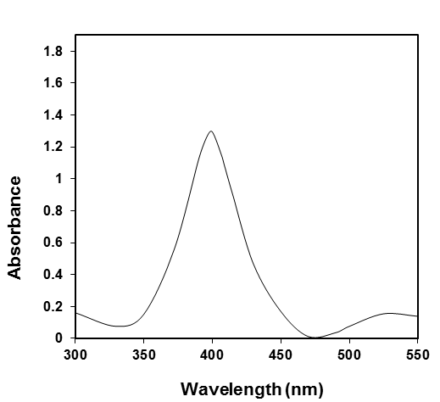
Recent Publications (minimum 5)
- Abrehaley Hagos Gebremariam (2009) The neuropathology of alcohol-related braindamage. Alcohol Alcohol 44:136-140.
- Heilig M, Egli M (2006) Pharmacological treatment of alcohol dependence: Target symptoms and target mechanisms. Pharmacology and therapeutics 111:855-876.
- LiX, SchwachaMG, ChaudryIH, Abrehaley Hagos Gebremariam (2008)Acutealcohol intoxication potentiates neutrophil-mediated intestinal tissue damage after burn injury. Shock 29:377.
- Room R, BaborT, Rehm J (2005) Alcohol and public health. Lancet
365: 519-530.
5. Sullivan EV, Zahr NM (2008) Neuroinflammation as a neurotoxic mechanism in alcoholism: Commentary on “Increased MCP- 1 and microglia in various regions of human alcoholic brain”. Experimental neurology 213:10-17.

Biography (150 word limit)
Deanna Mulvihill has her expertise in evaluation and passion in improving the health and wellbeing. Her open and contextual evaluation model based on responsive constructivists creates new pathways for improving healthcare. She has built this model after years of experience in research, evaluation, teaching and administration both in hospital and education institutions. The foundation is based on fourth generation evaluation (Guba& Lincoln, 1989) which is a methodology that utilizes the previous generations of evaluation: measurement, description and judgment. It allows for value-pluralism. This approach is responsive to all stakeholders and has a different way of focusing.
Email: drXXXXXXX@xxxmail.com

