 Official HD Photo University/Organization Logo

Title: Advance xxxxxxxx of xxxxxxxx leads to lower percentage of same day cancellations, increasing positive xxxxxxxx experience
Name: xxxxxxxx
University/Organization; State, City, Country.

Abstract: (Minimum 250 words Maximum 450 words)
In 2017, an estimated xxxxxxxx new cancer cases will be diagnosed (1). Many patients with a xxxxxx will need xxxxxxxx as part of their treatment. xxxxxxxx saw xxxxxxxx new patients in 2017, and performed over xxxxxxxx operating room anesthetics. Advanced assessment of xxxxxxxx for operating room procedures helps reduce the xxxxxxxx that occur on the same day of the scheduled procedure. Same day xxxxxxxx cause stress and frustration to all involved but most crucially for the patient and their family (2). The xxxxxxxx of a planned procedure has a negative impact on the xxxxxxxx.
Our xxxxxxxx assesses all patients with planned xxxxxxxx. All patients are screened using a xxxxxxxx, embedded into our xxxxxxxx and sent to our patients with the OR case is requested. All answers are validated with the patient by a xxxxxxxx. Patients are then either xxxxxxxx or called by xxxxxxxx to their planned procedure. xxxxxxxx have xxxxxxxx as indicated by their xxxxxxxx, and seen in clinic. Subspecialty xxxxxxxx are arranged as needed. The remaining xxxxxx had less complex medical history and are assessed by phone.
xxxxxxxx maintains a same day cancellation rate of xxxxxxxx assessing patients before their procedure date through xxxxxxxx with each patient by our providers. This contributes to xxxxxxxx experience in the xxxxxxxx.

Keywords: Health Science, E-Health, Nursing Technology, Nursing Leadership, Nurse Practitioners.

Images/Graphs/Tables:

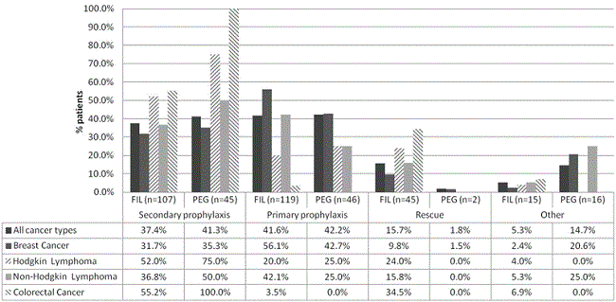

Recent Publications:
- Ting, F.I., Campos, H.J., Riel, A.(2015). Colo-cutaneous Fistula Complicating Diverticulitis of the Sigmoid Colon after Appendectomy: A Case Report and Review of Literature. Presented to the Philippine College of Physicians Research Conference December 2015.

- Ting, F.I., Parreñas, C., Palo, K., Seralde, A., Yasa, K., Yu, S. (2012) Perception and Knowledge of University of St. La Salle Students on the University’s Disaster Preparedness.

- Ting, F.I., Calmerin, E., del Rosario, B., Granada, M.E., Seralde, A., Trespeces, A.G. (2011). Water, Dug Wells, and People.

- Ting, F.I., Calmerin, E., del Rosario, B., Granada, M.E., Seralde, A., Trespeces, A.G. (2011). Physical and Chemical Properties of Water from Dug Wells at Purok Kaingin II, Barangay Punta Taytay, Bacolod City, Negros Occidental, Philippines.

- Ting, F.I., Abella, M.K., Corrales, M.C., Centina, M.K., Nonato, R.J., Santos, F. (2010). The Hypocholesterolemic Effect of the Crude Methanolic Extract of Radish Leaves (Raphanus Sativus) on the Total Cholesterol Level of Rabbits with Induced Hypercholesterolemia.

Biography: (Minimum 150 words Maximum 250 words)
xxxxxx B.A University of Kansas 1996, M.D. Tulane University School of Medicine 2003, Anesthesia Residency Tulane University 2007, Cardiovascular Anesthesia Fellowship Texas Heart Institute 2008. Associate Professor of xxxxxx 2008-current. Research and interests-maximizing efficiency in patient driven xxxxxx application of information technology to xxxxxxxx, and time driven activity based xxxxxx applied to healthcare setting. Published and/ or presented over 50 abstracts and peer reviewed publications.

Presenting author details
Full name (As per the passport):
University/Industry/Organization name (Present working):
Designation(Director/Prof/Assistant or Associate prof/Researcher/ Scientist /PhD Student):
Country:
Mobile number (country code – number) :
Official Email ID:
Presentation type (Oral/Poster):
Category (Invited talk/Young researcher Invited talk/E-poster):
Track number (This is very important to schedule your talk): Follow this link – https://nursinginterventions.nursingmeetings.com/
Research interest:

Your profile page URL in your department:
Date of birth as per the passport:
Linked In/Facebook/twitter account:
Postal address:

Note: Please fill up the Red mark fields so that it would be easier for us to cite your details in the conference particulars. (Please do not forget to fix your photo and Logo above the title)

