Nanoparticles for drug delivery to the brain
Abstract (600 word limit)
The use of nanoparticles to carry drug molecules across the blood–brain barrier (BBB) is known as nanoparticles for drug delivery to the brain. These medications cross the BBB and deliver pharmaceuticals to the brain for neurological diseases treatment. Due to their unique and revolutionary qualities, expanding the use of nanomaterials in the domains of biomaterials, biosensors, nano electronics, and catalysis is of significant interest. Nanomaterials are described as materials with at least one dimension less than 100 nanometers that have certain qualities as a result of their small size. Nanomaterials can be classified into zero-dimensional, which includes nanoparticles and quantum dots, one-dimensional, which includes nanofibers, nanotubes, and nanowires, two-dimensional, which includes graphene and graphene oxide, and three-dimensional, which includes equiaxed nanometer sized grains and is characterised by their structure. Some materials, on the other hand, may be put on the outskirts of these groups. Furthermore, nanomaterials can be created chemically, physically, physiologically, or mechanically, or they can occur naturally. Due to their small size and large surface area, drug nanoparticles show increase solubility and thus enhanced bioavailability, additional ability to cross the blood brain barrier (BBB), enter the pulmonary system and be absorbed through the tight junctions of endothelial cells of the skin. Their main advantages are namely sustained release, incremental drug selectivity and effectiveness, improvement of drug bioavailability and alleviation of drug toxicity. Nanocapsules, which are submicron in size, when administered intravenously, reach to the target and release the encapsulated drug. In particular, they can enhance the therapeutic activity by prolonging drug half-life, improving solubility of hydrophobic drugs, reducing potential immunogenicity, and/or releasing drugs in a sustained or stimuli-triggered fashion.
Nanoparticles manufactured from natural and synthetic polymers (biodegradable and non-biodegradable) have gotten increased attention because they can be tailored for targeted drug delivery, improved bioavailability, and controlled medicine release from a single dose through system adaptation. Although nanoparticles are defined as having dimensions less than 0.1 m or 100 nm, big (size >100 nm) nanoparticles may be required for loading a significant amount of drug onto the particles, notably in the area of drug delivery. Many nanoparticles, unlike conventional imaging agents and treatments, are extremely stable in vivo, as evidenced by a recent study that claimed quantum dots may be kept in the body (and stay luminous) for more than 100 days. The use of nanoparticles to deliver medications to cancer cells is perhaps the most well-known application of nanotechnology in drug delivery under development. Particles have been created to attract sick cells, allowing for direct therapy of particular cells. Nanomedicine refers to the use of nanoparticles for medicinal delivery. Because the amount of drug that can be placed on a single nanoparticle is restricted, and their capacity to control drug release is predicated on a single trigger, such as particle dissolution, nanoparticle-based drug delivery systems are constrained. Nanoparticles are zero-dimensional nanomaterials that can be classified as organic, inorganic, or composite nanoparticles based on their nature. The development of systematic toxicological investigations, which can prevent the production of neurotoxic effects, is critical in the treatment of brain illnesses. The most immediate challenge in nanotechnology is that we need to learn more about materials and their properties at the nanoscale. Universities and corporations across the world are rigorously studying how atoms fit together to form larger structures. Some examples of semiconductor nanoparticles are GaN, GaP, InP, InAs from group III-V, ZnO, ZnS, CdS, CdSe, CdTe are II-VI semiconductors and silicon and germanium are from group IV. Polymeric nanoparticles are organic based nanoparticles

Importance of Research: (200 word limit)
The number of people who die as a result of neurological or neurodegenerative disorders is comparable to the number of people who die in a war, with tremendous socioeconomic consequences and expenses. The presence of BBB, which is impassable by most currently available and potentially beneficial medications, makes treatment of such disorders difficult. As a result, both the academic and pharmaceutical communities have a significant challenge in discovering and developing innovative drug delivery systems for the treatment of such disorders. Nanotechnology is a cutting-edge and promising approach. Several varieties of NPs are already accessible for biomedical usage, each with its own set of characteristics and applications for enabling the delivery of neuroactive substances including medicines, growth factors and genes, and cells to the brain. NPs have clinical benefits for medication delivery, including lower drug doses, less side effects, longer drug half-life, and the potential to improve drug crossing over the BBB. However, despite being highly promising, the improvement in brain delivery achieved with drug-loaded NPs is still quantitatively restricted when compared to free medicines. As a result, with a few exceptions, NPs are not currently a feasible pharmacological solution, requiring one-order-of-magnitude or greater improvements.
More research is needed to gain a better understanding of the mechanisms that control the various NPs-mediated drug transport to the brain.
Image
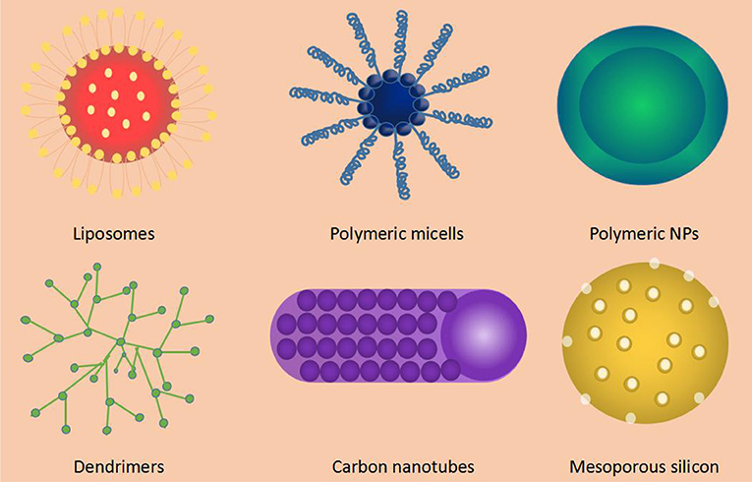

Information of the institute:

​ Kurdistan University of Medical Sciences (Persian: دانشگاه علوم پزشکی و خدمات بهداشتی درمانی کردستان) is a public university in Sanandaj, Iran. The University has five faculties including medicine, dentistry, health care, nursing, and paramedicine and 38 Departments within the University Campus offering different courses including B.Sc., B.E., Non-continuous B.Sc., M.Sc., M.Tech., M.D., Specialist, Subspecialist, PhD, PhD by Research, and Postdoc

Recent Publications (minimum 15)
1. Acharya MM, Christie LA, Lan ML, Donovan PJ, Cotman CW, et al. . Rescue of radiation-induced cognitive impairment through cranial transplantation of human embryonic stem cells. Proc Natl Acad Sci U S A 106: 19150–19155
2. Acharya MM, Christie LA, Lan ML, Giedzinski E, Fike JR, et al. . Human neural stem cell transplantation ameliorates radiation-induced cognitive dysfunction. Cancer Res 71: 4834–4845
3. Acharya MM, Christie LA, Lan ML, and Limoli CL. Comparing the functional consequences of human stem cell transplantation in the irradiated rat brain. Cell Transplant 22: 55–64
4. Adams MJ, Lipshultz SE, Schwartz C, Fajardo LF, Coen V, et al. . Radiation-associated cardiovascular disease: manifestations and management. Semin Radiat Oncol 13: 346–356
5. Aggarwal S. and Pittenger MF. Human mesenchymal stem cells modulate allogeneic immune cell responses. Blood 105: 1815–1822
6. Ahmad SS, Duke S, Jena R, Williams MV, and Burnet NG. Advances in radiotherapy. BMJ 345: e7765
7. Akita S, Akino K, Hirano A, Ohtsuru A, and Yamashita S. Noncultured autologous adipose-derived stem cells therapy for chronic radiation injury. Stem Cells Int 2010: 532704
8. Amit M, Carpenter MK, Inokuma MS, Chiu CP, Harris CP, et al. . Clonally derived human embryonic stem cell lines maintain pluripotency and proliferative potential for prolonged periods of culture. Dev Biol 227: 271–278
9. Anderson AJ, Haus DL, Hooshmand MJ, Perez H, Sontag CJ, et al. . Achieving stable human stem cell engraftment and survival in the CNS: is the future of regenerative medicine immunodeficient? Regen Med 6: 367–406
10. Andreyev HJ, Wotherspoon A, Denham JW, and Hauer-Jensen M. Defining pelvic-radiation disease for the survivorship era. Lancet Oncol 11: 310–312
11. Anversa P, Leri A, Rota M, Hosoda T, Bearzi C, et al. . Concise review: stem cells, myocardial regeneration, and methodological artifacts. Stem Cells 25: 589–601
12. Arinzeh TL, Peter SJ, Archambault MP, van den Bos C, Gordon S, et al. . Allogeneic mesenchymal stem cells regenerate bone in a critical-sized canine segmental defect. J Bone Joint Surg Am 85-A: 1927–1935
13. Banh A, Xiao N, Cao H, Chen CH, Kuo P, et al. . A novel aldehyde dehydrogenase-3 activator leads to adult salivary stem cell enrichment in vivo. Clin Cancer Res 17: 7265–7272
14. Barcellos-Hoff MH. How do tissues respond to damage at the cellular level? The role of cytokines in irradiated tissues. Radiat Res 150: S109–S120
15. Bearzi C, Rota M, Hosoda T, Tillmanns J, Nascimbene A, et al. . Human cardiac stem cells. Proc Natl Acad Sci U S A 104: 14068–14073
16. Belmadani A, Tran PB, Ren D, and Miller RJ. Chemokines regulate the migration of neural progenitors to sites of neuroinflammation. J Neurosci 26: 3182–3191

Biography (200 word limit)
Sherko Nasseri, Ph.D. in molecular medicine, Assistant Professor, from Kurdistan University ofMedical Sciences, Iran. During my Ph.D. Thesis, I worked on the generation of Fam83h Knockout Mice by using the CRISPR/Cas9 method. Fam83h KO has shown the scruffy cover, dry eye phenotypes, and also these mice were smaller than the same age normal mice. In continuation of this project, we found that the WNT/B-Catenin pathway decreased. The Fam83h gene has a high expression level in the gastrointestinal tract. Given all that has been said, it brings me a critical question that how the fam83h gene play role in the gastrointestinal tract?
Email: sherko77.naseri@yahoo.com
Presenting author details
Full name: sherko nasseri
Contact number:+98-9397500310
Twitter account: https://twitter.com/SherkoJdyuuh
Linked In account: https://www.linkedin.com/in/sherko-nasseri-370948668
Session name/ number: genome editing
Category: (Oral presentation)

