Title: TITLE OF THE TALK
Name of the presenter1. Degination,

Abstract (300 word limit)

An abstract is a brief summary of a research article, thesis, review, conference proceeding, or any in-depth analysis of a particular subject and is often used to help the reader quickly ascertain the paper's purpose.[1] When used, an abstract always appears at the beginning of a manuscript or typescript, acting as the point-of-entry for any given academic paper or patent application. Abstracting and indexing services for various academic disciplines are aimed at compiling a body of literature for that particular subject.

The terms précis or synopsis are used in some publications to refer to the same thing that other publications might call an "abstract". In management reports, an executive summary usually contains more information (and often more sensitive information) than the abstract does.
Image
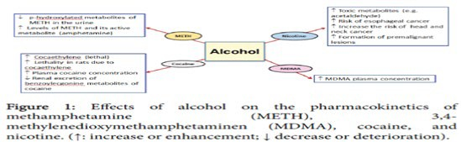

Recent Publications (minimum 5)

Kindly provide formally published article including (year of publication) title of the article. journal name. volume (issue): and page number

Biography (150 word limit)
Deanna Mulvihill has her expertise in evaluation and passion in improving the health and wellbeing. Her open and contextual evaluation model based on responsive constructivists creates new pathways for improving healthcare. She has built this model after years of experience in research, evaluation, teaching and administration both in hospital and education institutions. The foundation is based on fourth generation evaluation (Guba& Lincoln, 1989) which is a methodology that utilizes the previous generations of evaluation: measurement, description and judgment. It allows for value-pluralism. This approach is responsive to all stakeholders and has a different way of focusing.
Email:XXXXXXX@xxxmail.com
- Full Name:
- Personal Email:
- Mobile Number:
- Linked In:
- Facebook:
- Session Name/ number:
- Category: (Oral presentation/ Poster presentation)
- Date of Birth:
- Postal Address:

Notes or Comments:

