Women, trauma and alcohol dependency: Connections and disconnections in alcohol treatment for women

Name: xxxxxxxx
Stanford University School of Medicine, CA 94305, USA

Abstract

Encyclopedia of Bioanalytical Methods for Bioavailability and Bioequivalence Studies of Pharmaceuticals (E-BABE): It is a unique encyclopedia involving bioanalytical methods for bioavailability and bioequivalence (BA/BE) studies of pharmaceuticals for suitable method selection with thousands of combinations and searches against these methods. Most scrutinized literature was collected from different sources including PubMed. This database has been curetted using published methods for all most all pharmaceuticals. Required information for regular method development/validation such as IUPAC name, structure, solubility, chromatographic conditions, instrumentation information like HPLC, LCMS detection parameters, sample preparations, recovery details, limit of detection and limit of quantification, Tmax, Cmax etc., for routine application in BA/BE studies of pharmaceuticals was incorporated including official pharmacopeias information such as European Pharmacopeia, Japan Pharmacopeia and US Pharmacopeia. Database includes drug based bioanalytical methods covering most required fields and external database links of important drug portals such as drug bank, Rxlist, MEDLINE plus, KEGG Drug ID, KEGG Compound ID, Merck manual, PubChem compound ID, PubChem substance ID and USFDA. Searching/querying the database is through drug name, chemical formula or structural search by smiles format. Keen selections of bioanalytical methods for pharmaceutical analysis or regular quality control are also possible with E-BABE. E-BABE was built understanding the needs of pharmaceutical industry and laboratories including CROs working on BA/BE studies. Presently it has nearly of 5,000 methods and it will be updated regularly. (Limit 500 words)

Image
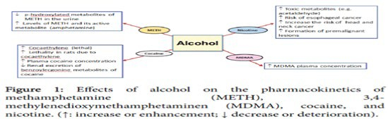
Recent Publications (minimum 3)
- Harper C (2009) The neuropathology of alcohol-related braindamage. Alcohol Alcohol 44:136-140.
- Heilig M, Egli M (2006) Pharmacological treatment of alcohol dependence: Target symptoms and target mechanisms. Pharmacology and therapeutics 111:855-876.
- LiX, SchwachaMG, ChaudryIH, ChoudhryMA (2008)Acutealcohol intoxication potentiates neutrophil-mediated intestinal tissue damage after burn injury. Shock 29:377.
- Room R, BaborT, Rehm J (2005) Alcohol and public health. Lancet
365: 519-530.
5. Sullivan EV, Zahr NM (2008) Neuroinflammation as a neurotoxic mechanism in alcoholism: Commentary on “Increased MCP- 1 and microglia in various regions of human alcoholic brain”. Experimental neurology 213:10-17.

Biography (Limit 250 Words): XXXX has completed his PhD at the age of 25 years from XXXX University and postdoctoral studies from Stanford University School of Medicine. He is the director of XXXX, a premier Bio-Soft service organization. He has built this model after years of experience in research, evaluation; teaching and administration also published more than 25 papers in reputed journals and has been serving as an editorial board member of repute.

Presenting author details
Full name:
E-mail:
Contact number:
Scientific Session name:
Category: (Oral/Poster presentation):
Facebook/Twitter account:

