Abstract Title
Replace with your Abstract Title
Name
Replace with your Name
University/Organization, Country/State
Replace with Your University/Organization Name, Country/State
Abstract (200-500 Words)
Replace with your Abstract
Research Work Related Image/Table (if Applicable)
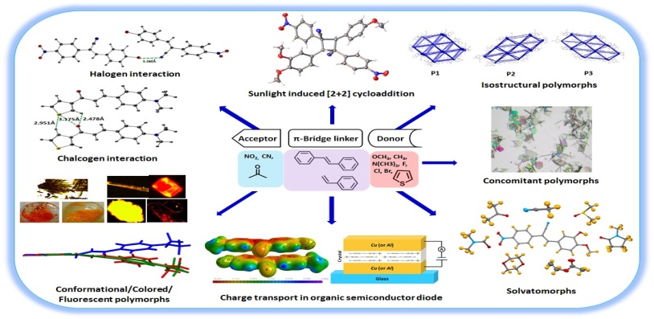
Recent Publications (3 to 5)
(Format of Recent Publications <Author Name (Year of Publication) Title. Journal Name (Volume number): Page Number.>)
- <Author Name (Year of Publication) Title. Journal Name (Volume number): Page Number.>)

Biography (100-200 words)
Replace with your Biography
E-mail
Replace with your E-mail ID
Mobile Number
Replace with your Mobile Number

Author Details
- Full Name:
- Linked in Account:
- Session/Track Name:
- Category (Oral Presentation/ Poster Presentation):
- Date of Birth:
- Postal Address:

Notes/Comments(if any)
Replace with your Comments(if/any)

