Official Photo University/Organization Logo

Women, trauma and alcohol dependency: Connections and disconnections in alcohol treatment for women
Deanna L Mulvihill, RN PhD, TLI Foundation, USA Deanna L Mulvihill, RN PhD, TLI Foundation, USA

Abstract (300 word limit)
Statement of the Problem: Women who have experienced Intimate Partner Violence (IPV) are at greater risk for physical and mental health problems including posttraumatic stress disorder (PTSD) and alcohol dependency. On their own IPV, PTSD and alcohol dependency result in significant personal, social and economic cost and the impact of all three may compound these costs. Researchers have reported that women with these experiences are more difficult to treat; many do not access treatment and those who do, frequently do not stay because of difficulty maintaining helping relationships. However, these women’s perspective has not been previously studied. The purpose of this study is to describe the experience of seeking help for alcohol dependency by women with PTSD and a history of IPV in the context in which it occurs. Methodology & Theoretical Orientation: An inter subjective ethnographic study using hermeneutic dialogue was utilized during participant observation, in- depth interviews and focus groups. An ecological framework was utilized to focus on the interaction between the counselors and the staff to understand this relationships and the context in which it occurs. Findings: The women in this study were very active help seekers. They encountered many gaps in continuity of care. (Up to 250 words)

Key words: AlGaN-Based Ultraviolet Laser Diodes, Laser EUV Radiation, photonics for quantum information, femtosecond laser, Quantum optics, CO₂ laser

Image
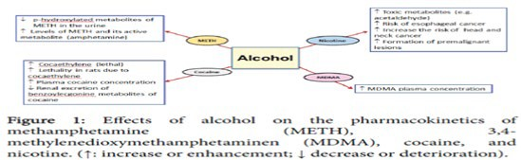
Recent Publications (minimum 5)
- Harper C (2009) The neuropathology of alcohol-related braindamage. Alcohol Alcohol 44:136-140.
- Heilig M, Egli M (2006) Pharmacological treatment of alcohol dependence: Target symptoms and target mechanisms. Pharmacology and therapeutics 111:855-876.
- LiX, SchwachaMG, ChaudryIH, ChoudhryMA (2008)Acutealcohol intoxication potentiates neutrophil-mediated intestinal tissue damage after burn injury. Shock 29:377.

Biography
Deanna Mulvihill completed his PhD in the year 1980 at the age of 25 years from XXX University. He is the Professor/director of XXXX, a premier Bio-Soft service organization. He has published more than 25 papers in reputed journals and has been serving as an editorial board member of repute. She is expertise in evaluation and passion in improving the health and wellbeing. Her open and contextual evaluation model based on responsive constructivists creates new pathways for improving healthcare. (Up to 100 words).

Presenting author details
Full name (As per the passport):
University/Industry/Organization name:
Designation (Director/Prof/Assistant or Associate prof/Researcher/Student):
Country:
Mobile number (country code – number):
Email:
Track number: https://magneticmaterials.physicsmeeting.com/call-for-abstracts.php (For track number follow this link)
Category (Oral presentation/ Poster presentation/Young researcher forum/E-poster):
Research interest:
Your profile page URL in your department:
Year of birth:
Linked In/Facebook/twitter account:

Note: Please fill up the Red mark fields so that it would be easier for us to cite your details in the conference particulars. (Please do not forget to fix your photo and Logo above the title)

