Atomic energy is the source of power for both nuclear reactors and nuclear weapons
Deanna L Mulvihill, RN PhD, TLI Foundation, USA Deanna L Mulvihill, RN PhD, TLI Foundation, USA

Abstract (300 word limit)

Atomic energy is the source of power for both nuclear reactors and nuclear weapons. This energy comes from the splitting (fission) or joining (fusion) of atoms. To understand the source of this energy, one must first understand the atom. An atom is the smallest particle of an element that has the properties characterizing that element. Knowledge about the nature of the atom grew slowly until the early 1900s. One of the first breakthroughs was achieved by Sir Ernest Rutherford in 1911. He established that the mass of the atom is concentrated in its nucleus. He also proposed that the nucleus has a positive charge and is surrounded by negatively charged electrons, which had been discovered in 1897 by J. J. Thomson. This theory of atomic structure was complemented by Niels Bohr in 1913. The Bohr atom placed the electrons in definite shells, or quantum levels. Understanding the atom continues to be a focus for many scientists. An atom is a complex arrangement of negatively charged electrons arranged in defined shells about a positively charged nucleus. This nucleus contains most of the atom's mass and is composed of protons and neutrons (except for common hydrogen which has only one proton). All atoms are roughly the same size. Scientific inquiry into the wave nature of light began in the 17th and 18th centuries, when scientists such as Robert Hooke, Christian Huygens and Leonhard Euler proposed a wave theory of light based on experimental observations. In 1803, Thomas Young, an English polymath, performed the famous double-slit experiment that he later described in a paper entitled On the nature of light and colors. This experiment played a major role in the general acceptance of the wave theory of light. In 1838, Michael Faraday discovered cathode rays. These studies were followed by the 1859 statement of the black-body radiation problem by Gustav Kirchhoff, the 1877 suggestion by Ludwig Boltzmann that the energy states of a physical system can be discrete, and the 1900 quantum hypothesis of Max Planck. Planck's hypothesis that energy is radiated and absorbed in discrete "quanta" (or energy elements) precisely matched the observed patterns of black-body radiation.
Image

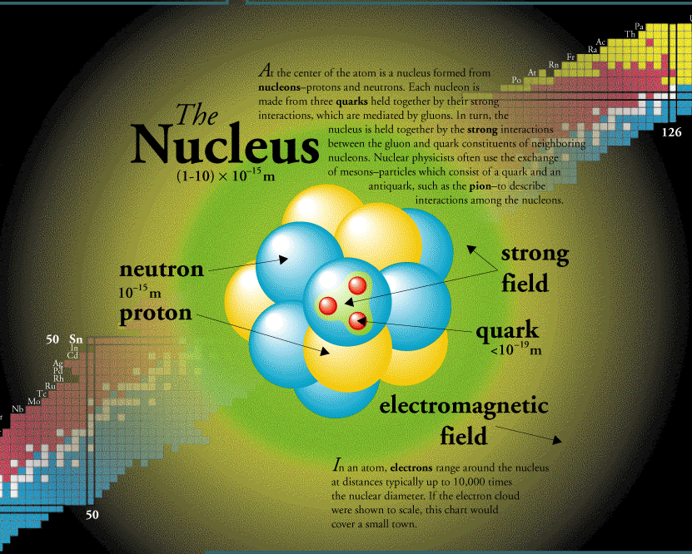
Recent Publications (minimum 5)

Strong-field control of x—ray absorption
R. Santra, C. Buth, E.R. Peterson, R.W. Dunford, E.P. Kanter, B. Krässig, S.H. Southworth, and L. Young.

K-edge x-ray-absorption spectroscopy of laser-generated Kr+ and Kr2+

S.H. Southworth, D.A. Arms, E.M. Dufresne, R.W. Dunford, D.L. Ederer, C. Höhr, E.P. Kanter, B. Krässig, E.C. Landahl, E.R. Peterson, J. Rudati, R. Santra, D.A. Walko, and L. Young

Electromagnetically Induced Transparency for X Rays"
Christian Buth, Robin Santra, and Linda Young

Quantum State-Resolved Probing of Strong-Field-Ionized Xenon Atoms Using Femtosecond High-Order Harmonic Transient Absorption Spectroscopy"
Zhi-Heng Loh, Munira Khalil, Raoul E. Correa, Robin Santra, Christian Buth, and Stephen R. Leone

Keywords :

Biography (150 word limit)
Deanna Mulvihill has her expertise in atomic and nuclear physics. She has completed his PhD at the age of 29 years from Harvard University and MIT - Massachusetts Institute of Technology. He is associated professor and director of a research team focusing on Atomic Physics and Nuclear Physics at Princeton University and Stanford University.
Email: drXXXXXXX@xxxmail.com

Notes/Comments:

Presenting author details
Full name:
University/Industry/Organization name:
Designation (Director/Prof/Assistant or Associate prof/Researcher/Student):
Country:
Mobile number(country code – number) :
Email ID:
Track name:
Category (Oral presentation/ Poster presentation/Young researcher forum/E-poster):
Research interest:
Linked In account:

Note: Please fill up the Red mark fields so that it would be easier for us to cite your details in the conference particulars. (Please do not forget to fix your photo above the title)

