Paste your Logo here
Paste your photograph here

Title: E-BABE-Encyclopedia of Bioanalytical Methods for Bioavailability and Bioequivalence Studies of Pharmaceuticals
XXXXX¹, YYYYY²
¹Vilnius Gediminas Technical University, Basanavicius 28, Vilnius LT-03224, Lithuania
²Technical University of Berlin, Ernst-Reuter Platz 1, Berlin D-10587, Germany

Abstract
The behaviour of non-biological spherical particles can be readily modelled with the discrete element method. The size of the particles thereby plays an important role in particle or particle system behaviour. For micron-sized particles the attractive force becomes dominant, thus specific knowledge is needed regarding it. This knowledge can be applied not only for non-biological, but also for biological similar sized objects, such as cells. This can extend the implementation, the understanding and possible applications of the discrete element method even up to the molecular dynamics level. The investigation of the dynamics of a single bacterium may help to understand the behaviour of a system of bacteria (e.g. biofilm formation) as well as the transmission of infections in the air. One of the important factors influencing the stability of a bacterial structure, but also important in the context of an infection is the adhesion force. Detailed results on the sticking process of a bacterium are presented. A characterisation of the influence of repulsive and attractive forces on the bacterium is given. The obtained results are shown in terms of force displacement diagrams as well as a function of the interaction and sticking time history. For the modelling of the system behaviour the sticking process of 10.000 bacteria is considered. (Upto 300-500 words)
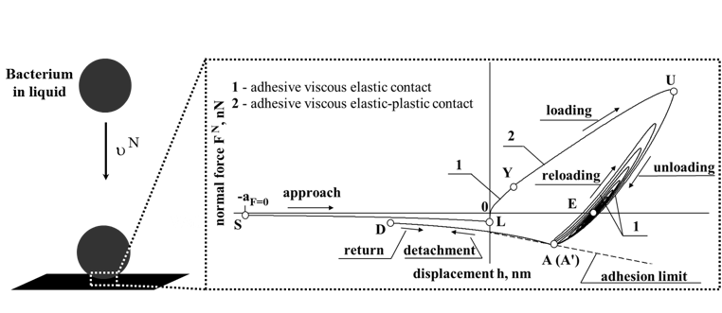
Fig. 1: Scheme for the motion of the bacterium close to the wall
Recent Publications (Minimum 3)
Biography
XXXX has completed his PhD at the age of 25 years from Oxford University and postdoctoral studies from Stanford University School of Medicine. He is the director of XXXX, a premier Bio-Soft service organization. He has published more than 25 papers in reputed journals and has been serving as an editorial board member of repute.
Scientific Session’s Name (Mandatory):
Email:
Phone No:
Category: Oral/Poster

