Significance of direct facial-hypoglossal nerve end to side neurorrhaphy for facial reanimation
Kazuo Ishikawa, DM, PhD. Japanese Red Croos, Akita Hospital, Japan

Abstract (300 word limit)
Facial disfigurement could affect our social life and even cause psychological problems. It is especially important when the nerve is severed during surgical treatment of acoustic neuroma, facial nerve tumor and temporal bone tumors. So far, interposition of free nerve graft or jump graft between facial and hypoglossal nerve will be the technique to be taken. However our recent technique of end to side facial-hypoglossal neurorrhapy relocating the vertical portion of the facial nerve could provide a better outcome when compared to the aforementioned previous techniques employed so far. Namely this technique could provide facial recovery up to the level nearly HB class II. We performed this technique in two cases with facial nerve tumor and one with acoustic neuroma.
The detail of these cases will be shown along with the other technique of so-called super charge in selected cases. Also several other techniques will be shown regarding facial nerve reconstruction used parotid cancer and so on.

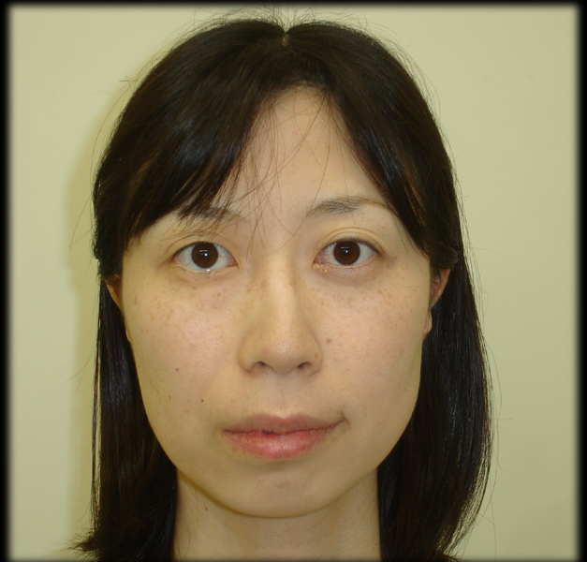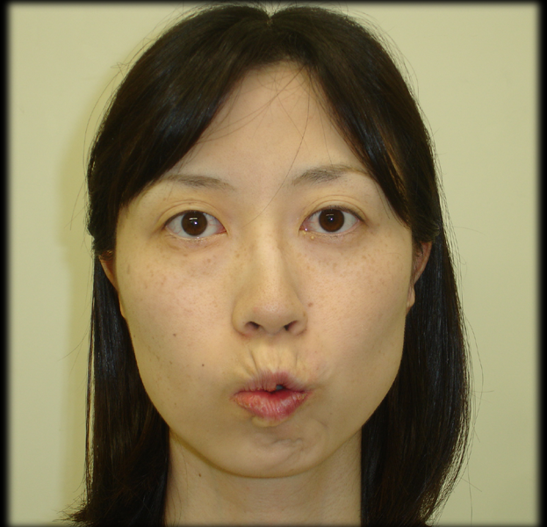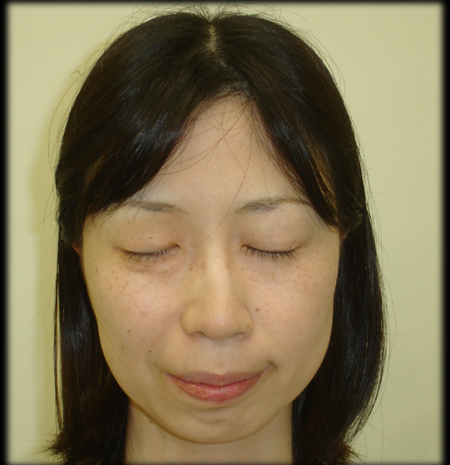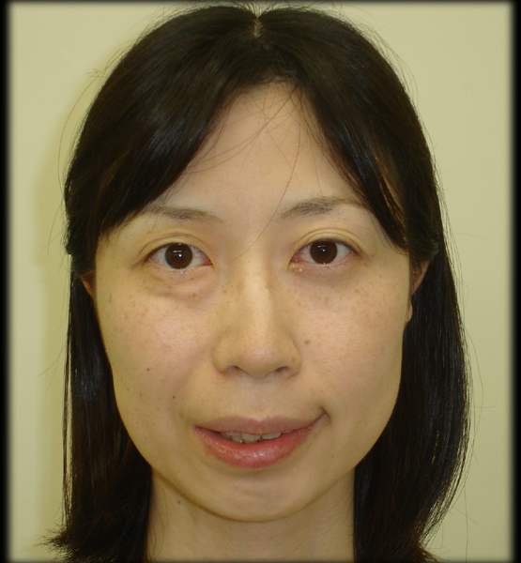

1.5 years after the surgery
Recent Publications (minimum 5)
- Mohamed A, Ishikawa K, et al: Giant cell tumor of the temporal bone invading into the pterygoid muscle through the temporomandibular joint Mohamed. J Neurol Surg Rep 75:136-140, 2014
- Mohamed A, Ishikawa K, et al: Large middle ear schwannoma of the Jacobson's nerve with intracranial extension. Auris Nasus Larynx 41:491-495, 2014
3. Mohamed A, Ishikawa K et al：Outcome of different facial nerve reconstruction techniques. Braz J Otorhinolaryngol 16: 30013-1. 2016
4. Wang Y, Ishikawa K et al: Giant cell tumor at the lateral skull base. Am J Otolaryngol 27:64-67, 2006
5. Mohamed A. Kazuo Ishikawa K. et al:Facial nerve neuroma in the geniculate ganglion extending into the internal auditory canal: A case report. ANL in press

red arrow: facial nerve tumor at geniculate ganglion

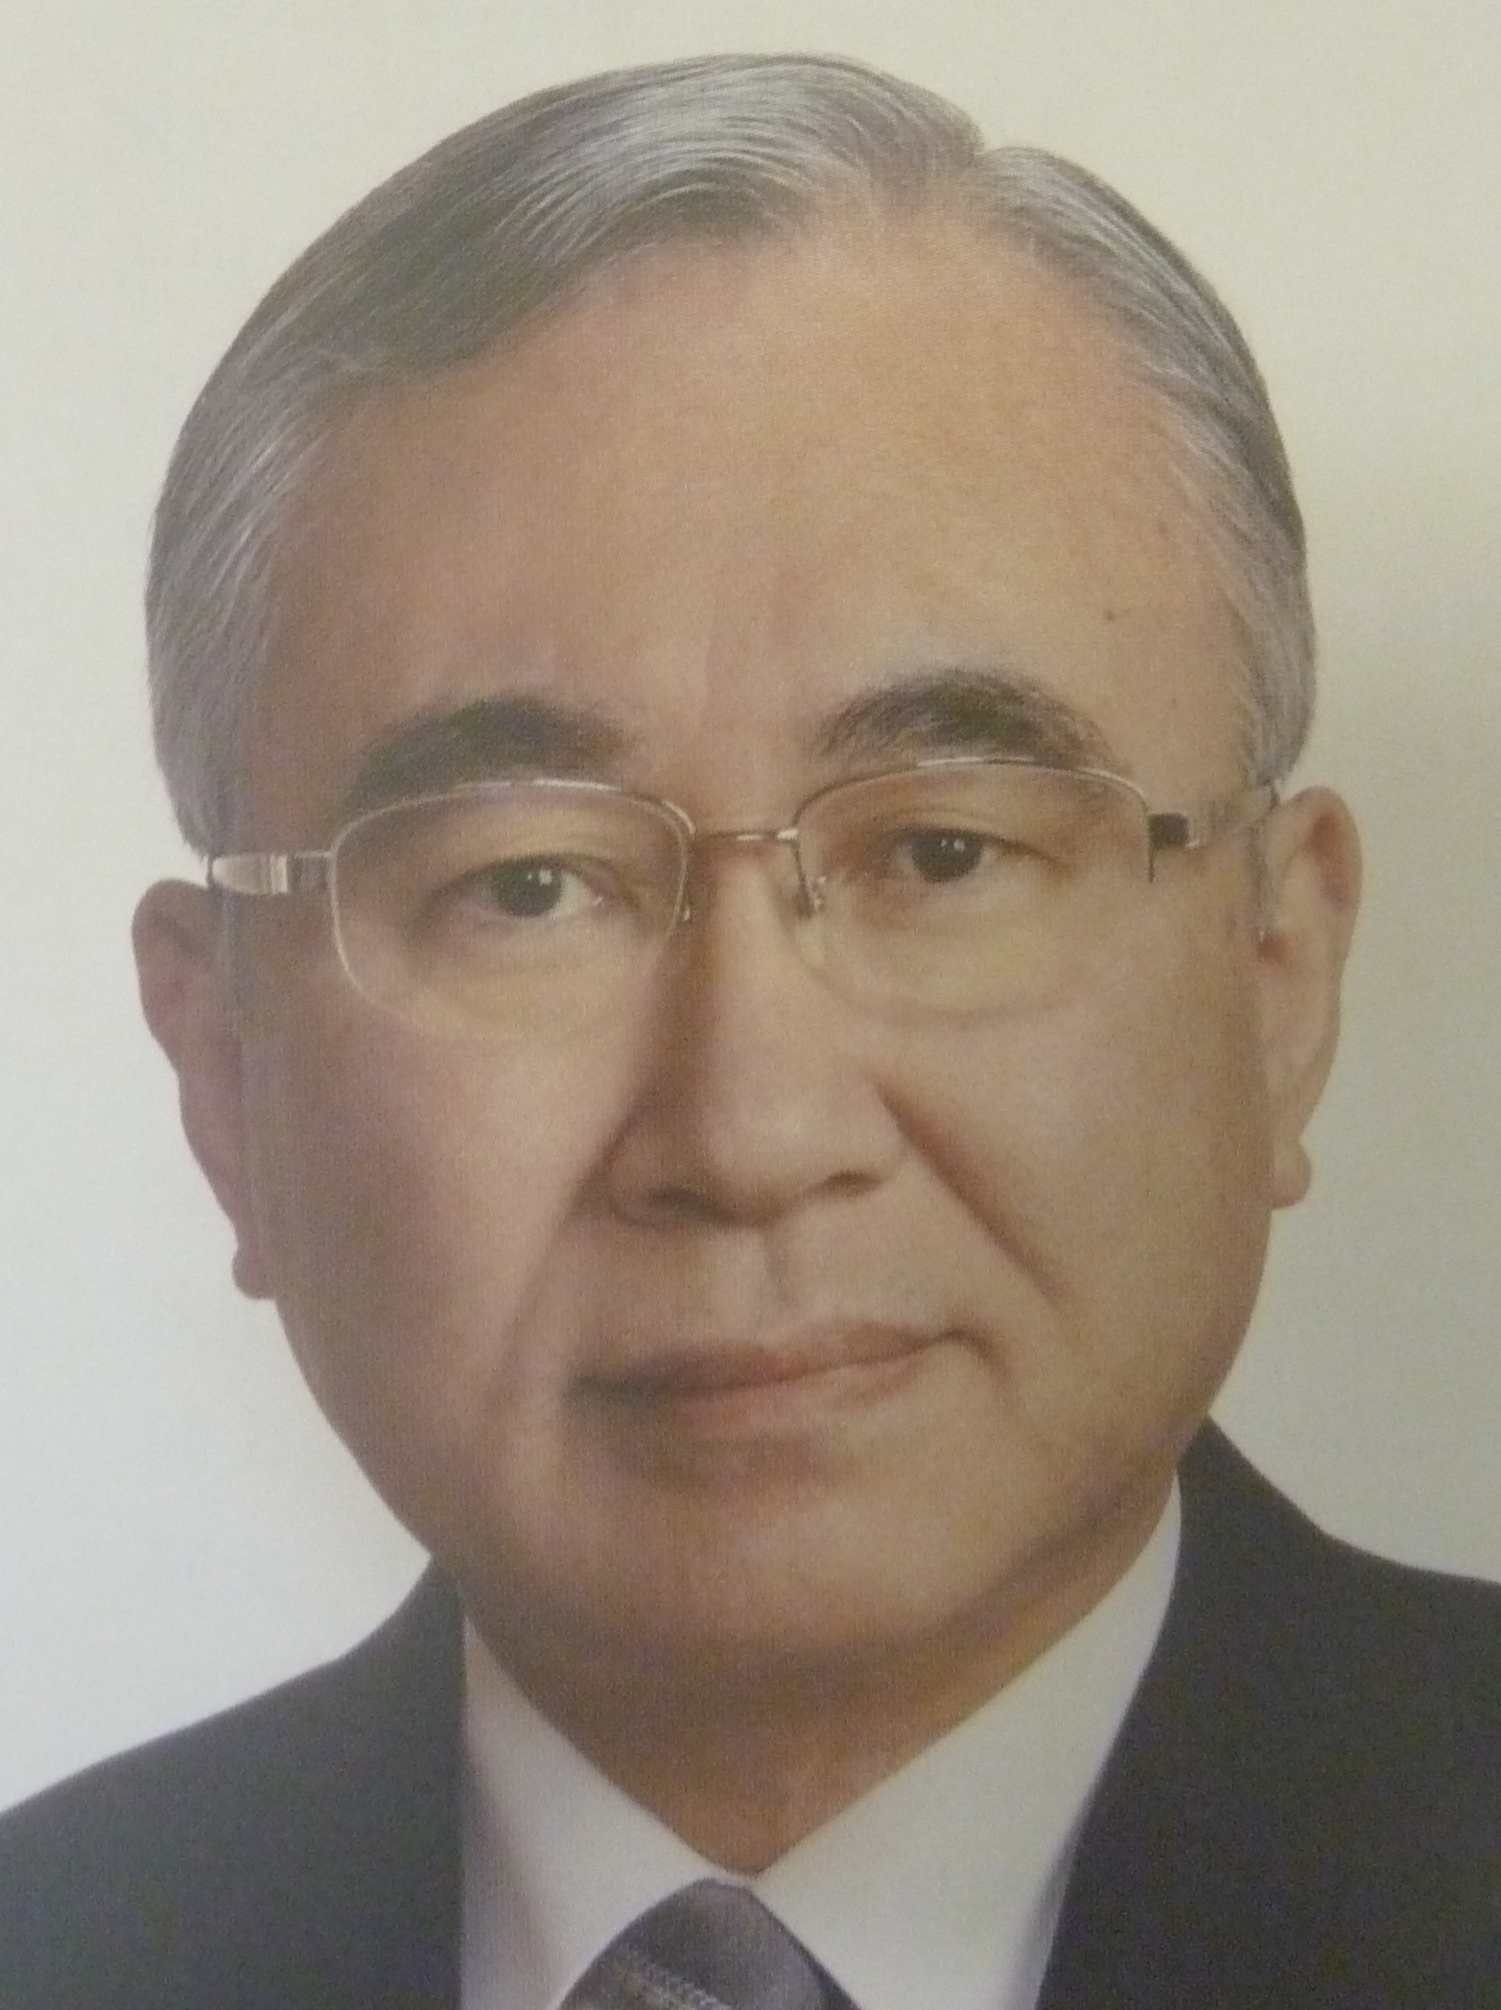Biography (150 word limit)
D Kazuo Ishikawa is specialized in neurotology, and has quite a few experiences of otological surgery along with acoustic neuroma surgery by MCF. He also contributed in diagnosis and treatment of facial nerve palsy. In 2016, he retired from Akita University, and then moved to Akita Red Cross Hospital where he is now working.
Email: ishioto@med.akita-u.ac.jp

Notes/Comments:

