Official Photo University/Organization Logo
E-BABE-Encyclopedia of Bioanalytical Methods for Bioavailability and Bioequivalence Studies of Pharmaceuticals
Deanna L Mulvihill, RN PhD, TLI Foundation, USA Deanna L Mulvihill, RN PhD, TLI Foundation, USA

Abstract (300 word limit)
Encyclopedia of Bioanalytical Methods for Bioavailability and Bioequivalence Studies of Pharmaceuticals (E-BABE): It is a unique encyclopedia involving bioanalytical methods for bioavailability and bioequivalence (BA/BE) studies of pharmaceuticals for suitable method selection with thousands of combinations and searches against these methods. Most scrutinized literature was collected from different sources including PubMed. Keen selections of bioanalytical methods for pharmaceutical analysis or regular quality control are also possible with E-BABE. E-BABE was built understanding the needs of pharmaceutical industry and laboratories including CROs working on BA/BE studies. Presently it has nearly of 5,000 methods and it will be updated regularly. (Up to 250 words)

Key words: AlGaN-Based Ultraviolet Laser Diodes, Laser Euv Radiation, photonics for quantum information, femtosecond laser, Quantum optics, CO2 laser

Image
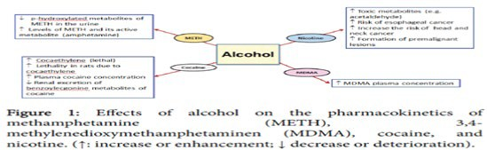
Recent Publications (minimum 5)
- Harper C (2009) The neuropathology of alcohol-related braindamage. Alcohol Alcohol 44:136-140.
- Heilig M, Egli M (2006) Pharmacological treatment of alcohol dependence: Target symptoms and target mechanisms. Pharmacology and therapeutics 111:855-876.
- LiX, SchwachaMG, ChaudryIH, ChoudhryMA (2008)Acutealcohol intoxication potentiates neutrophil-mediated intestinal tissue damage after burn injury. Shock 29:377.

Biography
Deanna Mulvihill has her expertise in evaluation and passion in improving the health and wellbeing. Her open and contextual evaluation model based on responsive constructivists creates new pathways for improving healthcare. (Up to 100 words).

Presenting author details
Full name (As per the passport):
University/Industry/Organization name:
Designation (Director/Prof/Assistant or Associate prof/Researcher/Student):
Country:
Mobile number (country code – number):
Email:
Track number: https://dentistrycongress.dentistryconferences.com/call-for-abstracts.php (For track number follow this link
Category (Oral presentation/ Poster presentation/Young researcher forum/E-poster):
Research interest:
Your profile page URL in your department:
Year of birth:
Linked In/Facebook/twitter account:

Note: Please fill up the Red mark fields so that it would be easier for us to cite your details in the conference particulars. (Please do not forget to fix your photo and Logo above the title)

