International Conference on
Advanced Metabolomics and Systems Biology

Deanna L Mulvihill, RN PhD, TLI Foundation, USA Deanna L Mulvihill, RN PhD, TLI Foundation, USA

Abstract (300 word limit)

Metabolomics is the study of chemical processes involving metabolites, molecular intermediates and products of metabolism. The rapidly emerging field of metabolomics combines strategies to identify and quantify cellular metabolites using sophisticated analytical technologies. Statistical and multi-variant methods are Metabolomics bridges the gap between genotype and phenotype. It provides a more comprehensive view of how cells function, identifying the striking changes in specific metabolites. used for information extraction and data interpretation.
Systems biology is the study of behaviour of complex biological organization. It is an interdisciplinary field which focuses on the complex interactions in biological systems. Two main approaches to computational systems biology are mechanistic dynamical simulations and inferential data mining. Significant development is occurring in both the areas. Further emerging techniques will improve the ability to bridge gap between human invitro and in vivo systems.
.

Image
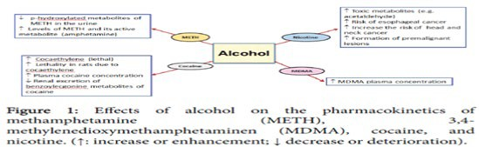
Recent publications (minimum 5)
- Harper C (2009) The neuropathology of alcohol-related braindamage. Alcohol Alcohol 44:136-140.
- Heilig M, Egli M (2006) Pharmacological treatment of alcohol dependence: Target symptoms and target mechanisms. Pharmacology and therapeutics 111:855-876.
- LiX, SchwachaMG, ChaudryIH, ChoudhryMA (2008)Acutealcohol intoxication potentiates neutrophil-mediated intestinal tissue damage after burn injury. Shock 29:377.
- Room R, BaborT, Rehm J (2005) Alcohol and public health.Lancet
365: 519-530.
5. Sullivan EV, Zahr NM (2008) Neuroinflammation as a neurotoxic mechanism in alcoholism: Commentary on “Increased MCP- 1 and microglia in various regions of human alcoholic brain”. Experimental neurology 213:10-17.

Biography (150 word limit)
Deanna Mulvihill has her expertise in evaluation and passion in improving the health and wellbeing. Her open and contextual evaluation model based on responsive constructivists creates new pathways for improving healthcare. She has built this model after years of experience in research, evaluation, teaching and administration both in hospital and education institutions. The foundation is based on fourth generation evaluation (Guba& Lincoln, 1989) which is a methodology that utilizes the previous generations of evaluation: measurement, description and judgment. It allows for value-pluralism. This approach is responsive to all stakeholders and has a different way of focusing.
Email: drdeanna.rpm@hotmail.com

Notes/Comments:

