Title:
Author Name, Degree, Organization Name, Country
e.g.: Ashish Kumar, PhD, MAAmalti Rehabilitation Centre, USA
- Abstract (300-word limits)
- Statement of the Problem
- Methodology & Theoretical Orientation
- Findings
- Conclusion & Significance
- Image (Optional)
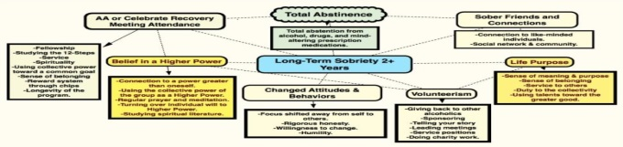
- Recent Publications [minimum-2 (If you have or leave this section)]
e.g.: Ashish Kumar, P. K. (2015). Theories of substance dependency, Counselling, Journal of Addiction Research & Therapy, 15 (2), 17-19
- Biography with Author image (150-word limits)
XXXX has completed his PhD at the age of 25 years from Singapore University and postdoctoral studies from Stanford University School of Medicine. He is the director of XXXX, a premier Bio-Soft service organization. He has published more than 25 papers in reputed journals and has been serving as an editorial board member of repute. (Up to 100 words).
- Presenting author details
- Full name:
- Email:
- Contact number:
- Research Interest:
- Current designation:
- Twitter account:
- Facebook account:
- LinkedIn account:
- Category: (Oral presentation/ Poster presentation/ Workshop)

Notes/Comments:

